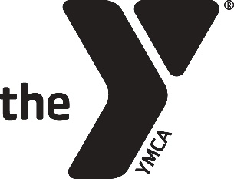

Platinum Sponsors - $2,000 \**Limited to 2 sponsors*

(Deadline November 15, 2018)

· Recognition and opportunity for short presentation before one Keynote Session

· Company information highlighted on conference social media platforms

· Logo on all webpages and a link to your website

· Listed as a conference sponsor in all print materials

· Placement of materials in our participant guide

· Logo on printed signs around conference

· Booth in our vendor fair

Gold Sponsors - $1,000

(Deadline November 15, 2018)

· Logo on all webpages and a link to your website

· Listed as a conference sponsor in our marketing brochure

· Placement of a one page flyer in our participant binder

· Logo on printed signs around conference

· Booth in our vendor fair

For questions, or to register as a sponsor, visit [www.ymcamacc.org/vendors](http://www.ymcamacc.org/vendors) or contact Bobby Thomas at 205-337-4897 or chair@ymcamacc.org

Silver Sponsors - $750

(Deadline November 15, 2018)

· Logo on all webpages and a link to your website

· Logo on printed signs around conference

· Booth in our vendor fair

The MACC draws YMCA professionals from the Mid America Region. Our participant base in 2018 included over 250 participants from 60 associations in 20 different states.

MID AMERICA CAMPING CONFERENCE

Sponsorship Information Form

Conference Dates: January 15-18

Location: YMCA Camp Copneconic—Fenton, MI